Industry Problem Task
CO2 AT1
MLA0303 – Reinforcement Learning
Submitted by

M Yasodha Krishna (192472100)
Under the Supervision of

Dr. Dumpala Prasanth

QUESTIONS: 10 Total Marks: 50

Annexure A

Industry Problem Task

1. Explain how Reinforcement Learning can be applied to optimize delivery routes in a logistics system. Identify the possible states, actions, rewards, and policy. Discuss how continuous learning improves efficiency over time. (5 Marks)
ANSWER:
1. Understanding of the Problem
- A logistics company wants to optimize delivery routes.
- The objective is to reduce travel time and fuel consumption.
2. Application of RL Concepts
State Space
- Vehicle location
- Traffic condition
- Delivery destination
- Fuel level
Action Space
- Select the next route
- Change delivery order
- Choose the shortest path
Reward Function
- Positive reward for faster delivery
- Positive reward for fuel savings
- Negative reward for delays and congestion
Policy
- Select the route that gives the highest long-term reward.
3. Problem-Solving Approach
- The RL agent learns from delivery experiences.
- It continuously updates routes based on traffic and rewards.
4. Outcome
- Reduced delivery time
- Lower fuel cost
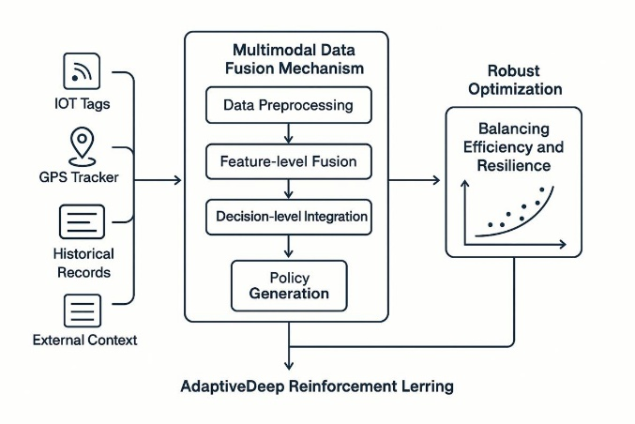
- Better customer satisfaction

2. Apply Reinforcement Learning concepts to a fraud detection system in fintech. Define the state space, action space, and reward mechanism. Explain how exploration strategies improve detection accuracy. (5 Marks)
ANSWER:
1. Understanding of the Problem
- Detect fraudulent financial transactions.
- Improve security while reducing false alarms.
2. Application of RL Concepts
State Space
- Transaction amount
- User location
- Transaction history
- Device information
Action Space
- Approve transaction
- Block transaction
- Request verification
Reward Function
- Positive reward for detecting fraud
- Negative reward for incorrect classification
Exploration
- Tests new fraud detection strategies.
- Learns new fraud patterns.
3. Problem-Solving Approach
- Learns from transaction outcomes.
- Updates fraud detection policy continuously.
4. Outcome
- Better fraud detection
- Reduced financial losses
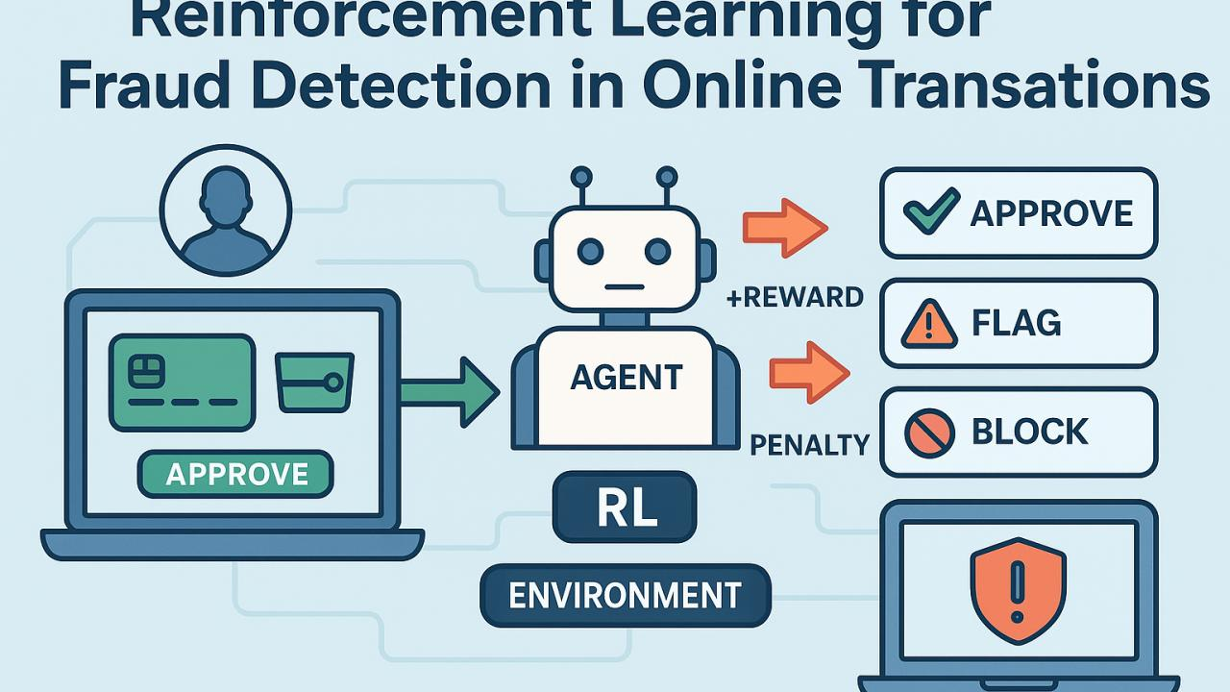
- Improved security

3. Illustrate how Reinforcement Learning is used in a streaming platform for content recommendation. Discuss the impact of delayed rewards, user feedback, and changing preferences on learning performance. (5 Marks)
ANSWER:
1. Understanding of the Problem
- Recommend movies and videos according to user interests.
2. Application of RL Concepts
Delayed Rewards
- User may watch content later.
- Rewards are received after user interaction.
User Feedback
- Likes
- Ratings
- Watch time
Changing Preferences
- User interests change over time.
- RL adapts recommendations continuously.
3. Problem-Solving Approach
- Learns from user behavior.
- Updates recommendation policy regularly.
4. Outcome
- Personalized recommendations
- Higher user engagement
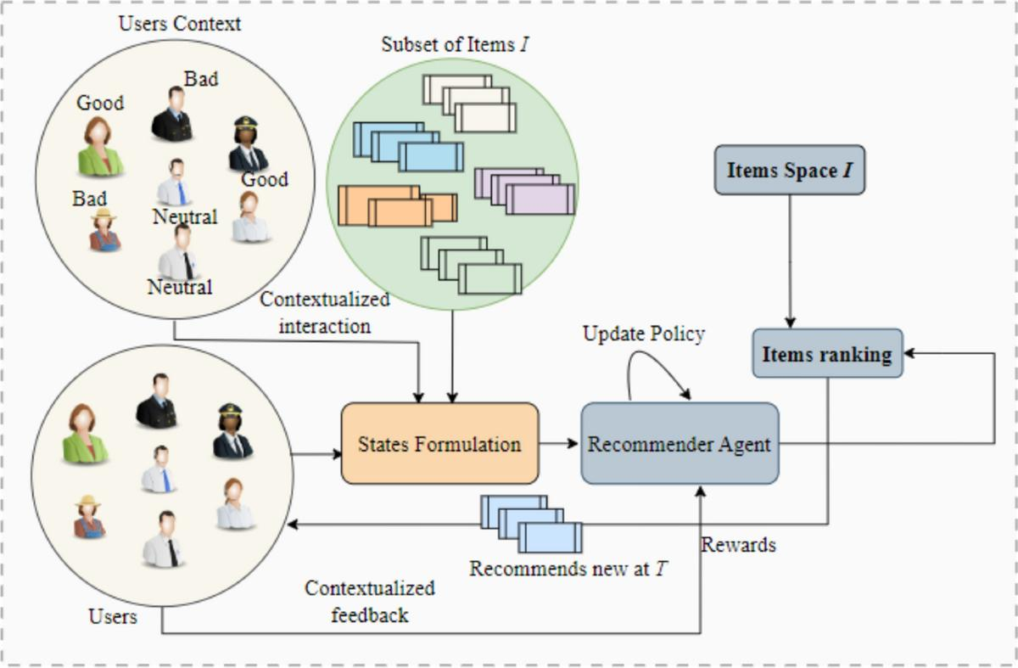
- Increased watch time

4. Evaluate the effectiveness of Reinforcement Learning in predictive maintenance compared to traditional rule-based approaches. Discuss risks and reliability concerns in industrial environments. (5 Marks)
ANSWER:
1. Understanding of the Problem
- Predict machine failures before breakdown.
2. RL vs Rule-Based System
Reinforcement Learning
- Learns from machine data.
- Adapts automatically.
- Improves maintenance scheduling.
Rule-Based System
- Uses fixed rules.
- Cannot adapt to new situations.
3. Risks
- Incorrect predictions
- Sensor failures
- Safety concerns
- Data quality issues
4. Outcome
- Reduced maintenance cost
- Less downtime
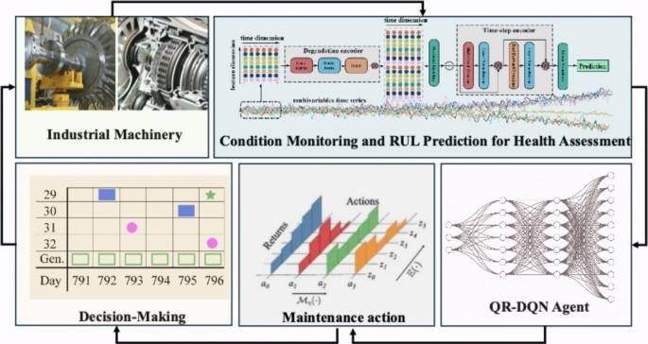
- Better equipment reliability

5. Analyze how Reinforcement Learning can be used to optimize transportation systems such as bus scheduling or route allocation. Define states, actions, and rewards, and discuss how real-time data improves performance. (5 Marks)
ANSWER:
1. Understanding of the Problem
- Improve bus scheduling and route allocation.
2. Application of RL Concepts
State Space
- Passenger demand
- Bus location
- Traffic condition
Action Space
- Change bus schedule
- Allocate buses
- Select routes
Reward Function
- Positive reward for on-time service
- Negative reward for delays
3. Problem-Solving Approach
- Uses real-time traffic and passenger data.
- Learns better scheduling policies.
4. Outcome
- Reduced waiting time
- Better resource utilization
- Improved public transport efficiency
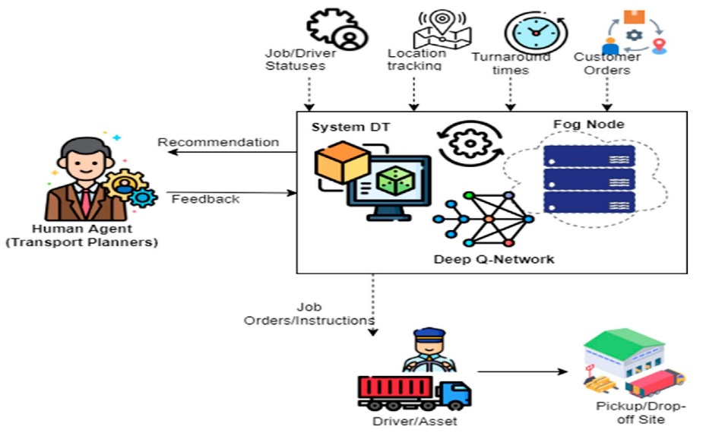

6. Apply Reinforcement Learning to dynamic pricing in e-commerce. Define the state space, action space, and reward function. Discuss challenges in balancing exploration and exploitation. (5 Marks)
ANSWER:
1. Understanding of the Problem
- An e-commerce company wants to adjust product prices automatically.
- The goal is to maximize profit while keeping customers satisfied.
2. Application of RL Concepts
State Space
- Product demand
- Current price
- Competitor prices
- Inventory level
- Customer buying behavior
Action Space
- Increase price
- Decrease price
- Maintain current price
- Offer discounts
Reward Function
- Positive reward for higher sales and profit
- Positive reward for increased customer purchases
- Negative reward for low sales or customer loss
3. Problem-Solving Approach
- The RL agent observes market conditions.
- It adjusts prices based on customer response.
- Exploration tests new prices, while exploitation uses profitable pricing strategies.
4. Outcome
- Increased revenue
- Better customer satisfaction
- Improved pricing strategy
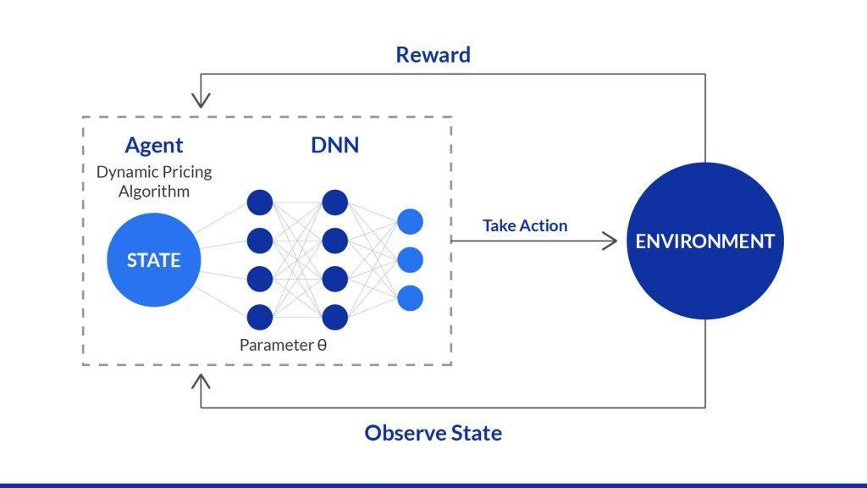
- Higher business profit

7. Illustrate the use of Reinforcement Learning in smart city waste management systems. Identify the MDP components and discuss how continuous updates improve operational efficiency. (5 Marks)
ANSWER:
1. Understanding of the Problem
- A smart city wants to optimize waste collection.
- The objective is to reduce fuel usage and collection time.
2. MDP Components
States
- Bin fill level
- Truck location
- Traffic condition
- Fuel level
Actions
- Select collection route
- Skip empty bins
- Dispatch another truck
Rewards
- Positive reward for efficient waste collection
- Positive reward for reduced fuel consumption
- Negative reward for overflowing bins
- Negative reward for unnecessary trips
3. Problem-Solving Approach
- The RL agent receives sensor data continuously.
- It updates collection routes based on changing conditions.
4. Outcome
- Reduced operational cost
- Cleaner city
- Faster waste collection
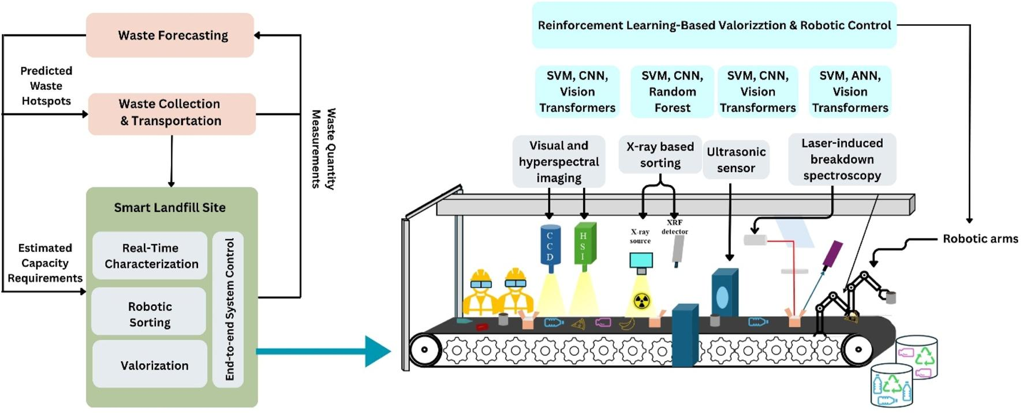
- Better resource utilization

8. Evaluate how Reinforcement Learning can be used in network bandwidth allocation in telecommunications. Define states, actions, and rewards, and examine how the system adapts to dynamic conditions. (5 Marks)
ANSWER:
1. Understanding of the Problem
- A telecommunications company wants to allocate bandwidth efficiently.
- The objective is to provide stable network performance.
2. Application of RL Concepts
State Space
- Network traffic
- Available bandwidth
- Number of users
- Network congestion
Action Space
- Increase bandwidth
- Reduce bandwidth
- Prioritize users
- Balance network load
Reward Function
- Positive reward for high network performance
- Positive reward for low latency
- Negative reward for congestion
- Negative reward for packet loss
3. Problem-Solving Approach
- The RL agent monitors network conditions.
- It adjusts bandwidth allocation dynamically according to traffic.
4. Outcome
- Better Quality of Service (QoS)
- Reduced network congestion
- Higher bandwidth utilization
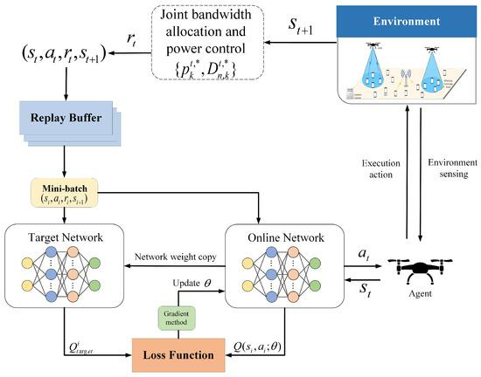
- Improved user experience

9. Analyze the application of Reinforcement Learning in portfolio management in finance. Discuss advantages over traditional models and challenges such as risk and delayed rewards. (5 Marks)
ANSWER:
1. Understanding of the Problem
- A financial institution wants to maximize investment returns.
- The goal is to manage investment portfolios efficiently.
2. Application of RL Concepts
Advantages
- Learns from market changes
- Makes adaptive investment decisions
- Optimizes long-term returns
- Handles dynamic financial markets
Challenges
- Delayed investment rewards
- Market volatility
- High financial risk
- Large amount of historical data required
3. Problem-Solving Approach
- The RL agent analyzes market conditions.
- It continuously updates investment decisions using reward feedback.
4. Outcome
- Improved portfolio performance
- Better risk management
- Higher long-term returns
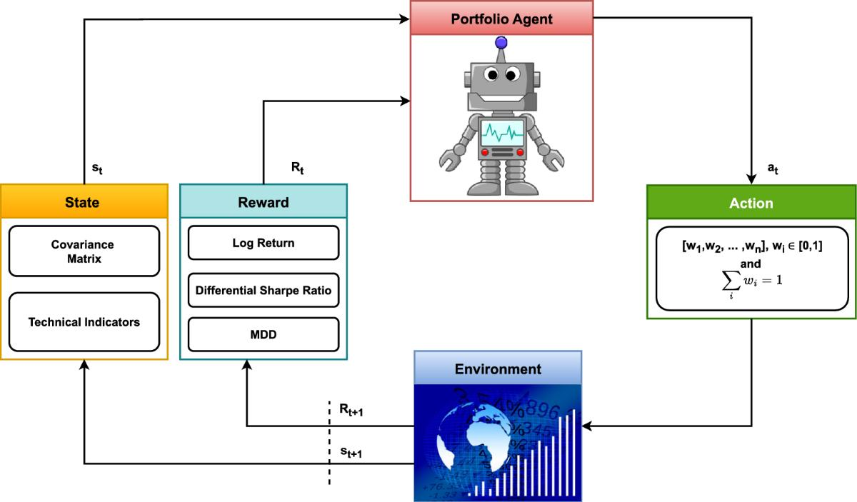
- Smarter investment decisions

10. Justify the use of Reinforcement Learning in renewable energy management systems. Define the RL framework components and discuss the impact of environmental uncertainty on decision-making. (5 Marks)
ANSWER:

1. Understanding of the Problem
- A renewable energy system manages solar and wind power efficiently.
- The objective is to balance energy generation and consumption.
2. RL Framework Components
State Space
- Solar power generation
- Wind speed
- Battery storage level
- Electricity demand
- Weather conditions
Action Space
- Store energy
- Supply energy to the grid
- Charge batteries
- Reduce energy usage
Reward Function
- Positive reward for efficient energy distribution
- Positive reward for maximum renewable energy utilization
- Negative reward for energy wastage
- Negative reward for power shortages
3. Problem-Solving Approach
- The RL agent monitors environmental conditions.
- It learns the best energy management strategy despite uncertain weather and changing demand.
4. Outcome
- Efficient renewable energy utilization
- Reduced energy wastage
- Reliable power supply
- Lower operational cost
- Sustainable energy management
